Running dynamic programming algorithms on a DNA computer
Eric B.Baum and Dan Boneh
In Proceedings of the Second Annal Meeting on DNA based Computers, 1996
- Introduction
DNA computers using dynamic programming could solve substantially large instances because of their large memory capacity than either conventional computers or previous brute force algorithms on DNA computers.
- Dynamic Programming
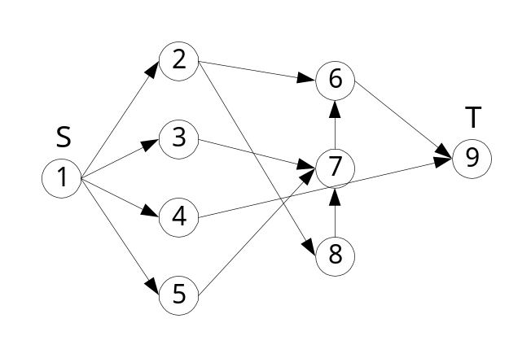
f₁(v)={2,3,4,5}
d=max{distance(u, v)| u, vV}=5
- Solving graph connectivity using DNA
How to run the BFS algorithm on a DNA computer?
- Start with a solution containing strands representing the vertex S.
- Iterate the following procedure d times where d is the diameter of the graph:
  - Let D be the current solution. Apply PCR to create m copies of the solution D. Let D₁, …, D_{m} be m separate vats containing the replicas of D.
  - We arrange things so that the strands in solution Di now look like:
3’ – v – B₁ – fi(v) – B₂ – 5’
where B₁ is the restriction site for some enzyme and B₂ is some fixed DNA strand.
  - In each D_{i} apply the restriction enzyme which cuts the strand at B₁. Then extract from D_{i} all strands containing the string B₂. Denote the set of extracted strands by D_{i}’.
  - Pour all of D₁’,…, D_{m}’ into one vat denoted by D’. Note that D’ now represents the set of all neighbors of vertices in D.
  - Test if the target vertex T appears in the solution D’. If it does stop. Otherwise set D ← D’ and go to step2.

Definition Let G be a graph with a distinguished vertex S. For an integer d>0 denote by P_{d}(V) the number of paths from S to V of length exactly d. Let
M(d)=max{P_{d}(V)} and N(d)=min{P_{d}(V)}
The graph G is called ε-balanced if for any d>0 we have N(d)/M(d)> ε

Our algorithm will only work for ε-balance graphs.
- Solving the knapsack problem
The knapsack problem we are interested in is the following: given positive integers b₁, …, b_{n} and an integer B, does there exist a subset 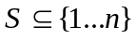 such that 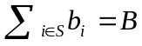.

The knapsack can easily be posed as a graph problem as follows:
There is an edge from point (x, i) to (y, i+1) if y=x or y=x+b_{i}.
Example B=10, b₄={2,3,4,5}
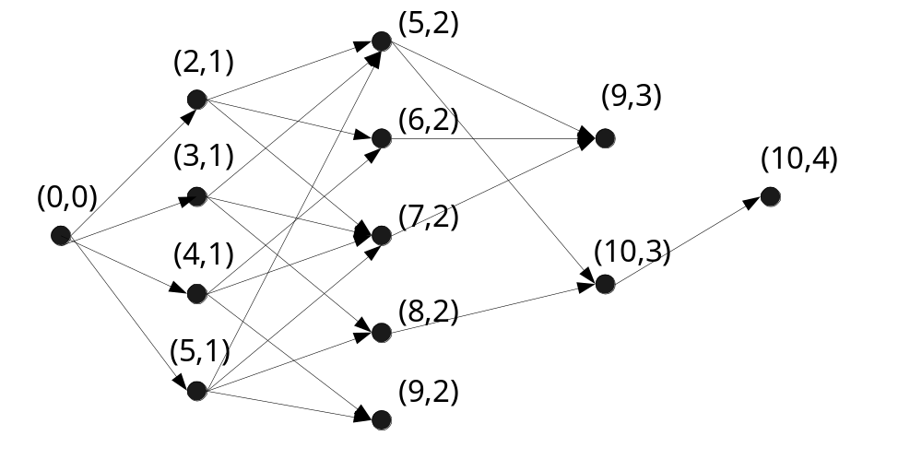
The knapsack problem has a solution if and only if there is a path in the above graph from (0,0) to (10,4).

To solve the knapsack problem using DNA we intend to use the graph connectivity algorithm of the previous section. We first need to discuss how to add numbers using DNA. We wish to transform the solution T to a solution T’ representing all numbers {α₁, α₁+X, …, α_{k}, α_{k}+X } for some integer X with m decimal digits. This can be done as follows:
- Let d be the least significant digit of X. Separate the solution T into 10 solutions T₀, T₁, …, T₉ such that T_{i} contains all numbers in T whose least significant digit is d.
- In each T_{i} append to all strands in T_{i} the oligo representing the digit i+d mod 10.
- Pour the solutions T₀,…, T_{9-d} into one vat T⁰. Pour the remaining solutions into another vat T¹. The strands in T⁰ represent those numbers that have not generated a carry. Similarity, the strands in T¹ represents those which generated a carry.
- Iterate this procedure appropriately for each of the m digits.
- At the end of the process all strands in the solution look like:
3’ –α_{i} – S – α_{i}+X – 5’
where S is some predetermined separator.
- Use a restriction enzyme to cut all strands at the string S. This will produce the required solution containing numbers {α₁, …, α_{n}, α₁+X, α_{n}+X }
- Conclusions
We noted that DNA computers might be useful for running dynamic programming algorithm since such algorithm require large amounts of memory for solving relatively simple tasks.

Due to the DNA molecules in a DNA computer are essentially oblivious of one another, and have no way to communicate. This example may also thus a limitation of DNA computers.
Created by: Yi-Ying Chen
Date: May. 10, 2001

